Ping -c 5 demo.ine.local
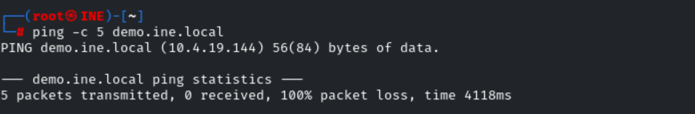
Nmap demo.ine.local
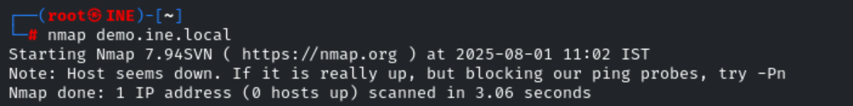
Now use the option -Pn and then directly scan the port and assume that the host is up (without discovering the host).
-Pn (Treat all hosts as online; skip host discovery).
nmap -Pn demo.ine.local
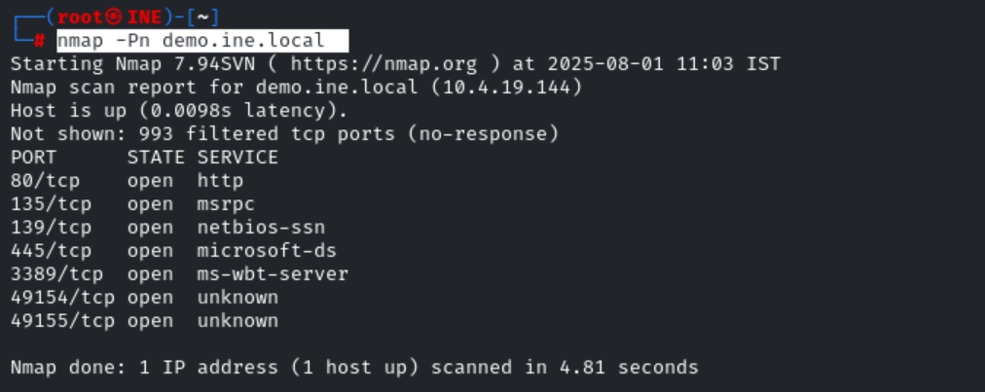
Now it show the result that it gets.
Now scan the random port:
The filtering could be from a dedicated firewall device, router rules, or host-based firewall software.
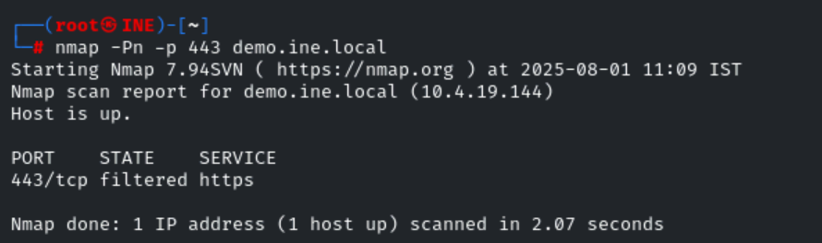
Nmap result:
Port Response | Nmap State | Explanation
No response | filtered | Blocked by firewall, can't determine state
RST flag sent back | closed | Port is reachable, but nothing listening

nmap -Pn -p 80 -sV demo.ine.local

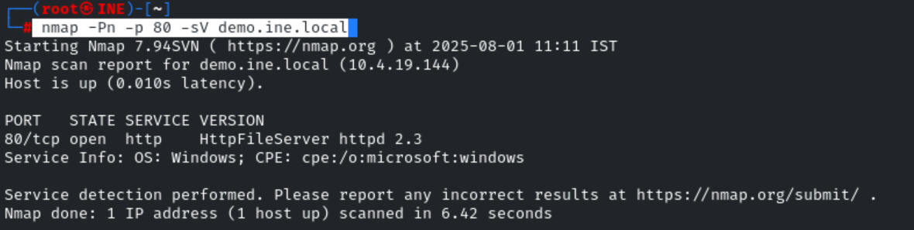

ICMP Type 3 Code 13 – Communication Administratively Prohibited
"The packet was blocked by a firewall or ACL (Access Control List) and cannot reach its destination."

